Baxter’s Bunch Newsletter 2025 Winter Edition – Valentine’s Day

**Hi Kids!**

Baxter the Bear wants to wish you all a Happy Valentine’s Day! This edition has trivia, fun activities, book recommendations, and tips and tricks to setting up and building a saving’s fund with your Baxter’s Bunch Savings’ account at Del Norte Credit Union. Read along, have fun with the activities and knowledgeable facts, and I encourage you to make good financial decisions!

With a big bear high-five!

Baxter the Bear

**Happy Valentine’s Day**

Valentine’s Day is always on February 14th, which falls on a Friday this year!

Did you know that Valentine’s Day is a special day to celebrate love and friendship? Here are some other fun trivia facts about Valentine’s Day.

Valentine’s Day Fun Trivia

1. The first ever Valentine’s Day was in the year of 496 – 1,529 years ago – to celebrate the day of love as a Roman festival called Lupercalia.
2. Red, pink, and white are the three main colors represented on Valentine’s Day!
3. The most popular Valentine’s Day candy is a box of chocolates.
4. Teachers receive the most Valentine’s Day cards in the United States.
5. Cadbury created the first ever heart-shaped box of chocolate treats.
6. Over 58 million pounds of chocolate are consumed on Valentine’s Day.
7. Valentine's Day is said to be the second most popular day to send cards, after Christmas!
8. An estimated 190 million Valentine’s Day cards are distributed on Valentine’s Day!
9. X’s and O’s mean hugs and kisses.
10. Roses are the most popular Valentine’s Day flower.

**Valentine’s Day Word Search**

[Use this as inspiration and make it Baxter the Bear brand. Thank you! URL: <https://www.pinterest.com/pin/educational-coloring-pages--509469776596864735/>]

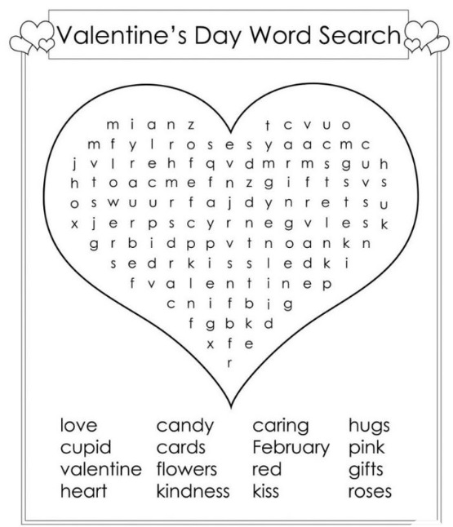

**Valentine’s Day Word Scramble**

[Use this as inspiration and make it Baxter the Bear brand. Thank you! URL: <https://crayonsandcravings.com/valentines-word-scramble/>]

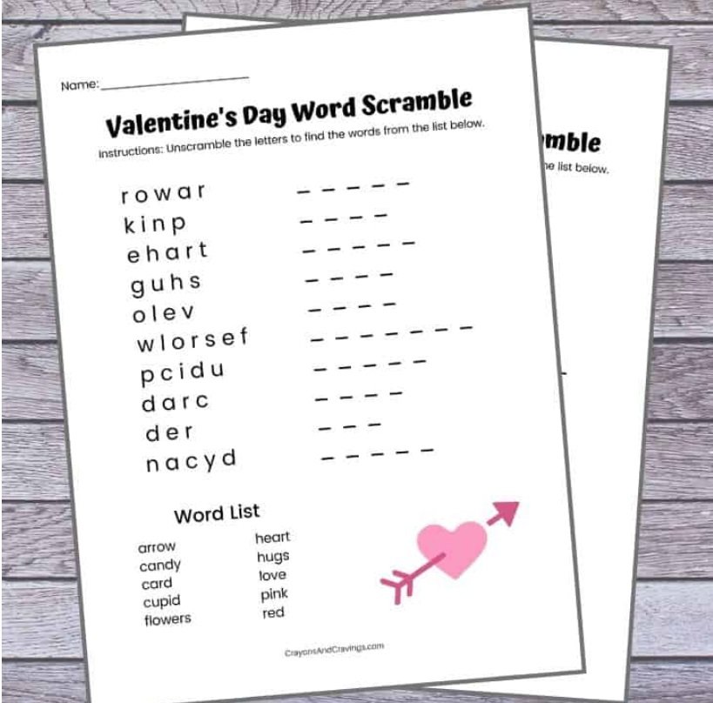

**Baxter the Bear Photo Contest**

We thank Eliseo E., who is five years old and loves to fish, for being our Fall 2024 Photo Contest Winner!

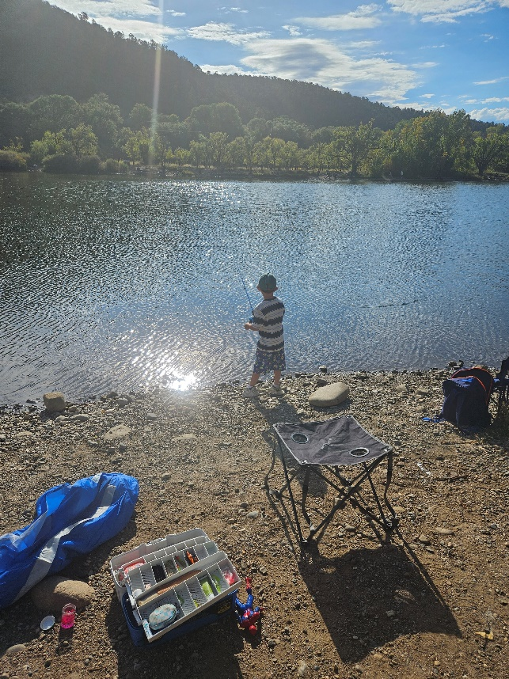

Baxter the Bear wants to see you be active this winter – whether it be outside in the snow, tubing, skiing, or making a snowman! Show us how much fun you’re having this winter and submit a photo, with parent and/or legal guardian permission, by March 15, 2025 to [baxter@dncu.org](mailto:baxter@dncu.org). The winner will be announced in our 2025 Spring edition and will receive a deposit of $25 into their Baxter’s the Bunch savings account. Thanks for participating!

**Parent’s Corner**

We thank you and your family for being a Del Norte Credit Union member! As a member, you have access to products, services, and resources that can help you reach your goals, no matter where you are in your financial journey. As a reminder, we offer a Debt Consolidation Loan to help you combine your debt into one monthly bill with one fixed rate and payment plan! Visit our webpage, <https://www.dncu.com/debt-consolidation/>, to learn more how you can simplify your finances. You can always visit our branches and or call us at 505-455-5228 to talk to a DNCU staff member today to talk further about this important loan.

P.S. Visit DNCU branches from February 3 – February 14, 2025 to purchase a chocolate sweet treat box and/or a Baxter the Bear plush stuffed animal as a donation to support Del Norte LOV Foundation’s At-Risk Youth initiatives. We thank you for your support!

**Financial Literacy Tip**

Baxter the Bear wants you to set good intentions this year and save with your Baxter’s Bunch Savings Account at Del Norte Credit Union. He recommends a good checklist to get things started. We encourage you to sit with your parent and/or legal guardians to help you consider answering these important financial questions!

1. Set a goal and write it down!

Savings Goal: ___________________________________________________________________

______________________________________________________________________________

1. Set a goal numerical amount!

Savings Amount: $_______

1. Be specific about what you want.

What do I want to save for? _______________________________________________________

______________________________________________________________________________

______________________________________________________________________________

1. Be positive in your goal setting! Goals can change and that’s totally ok and understandable!
2. Keep track of your progress and celebrate milestones to stay focused and motivated.

Spring tracking: _________________________________________________________________

Summer tracking: _______________________________________________________________

Fall tracking: ____________________________________________________________________

Winter tracking: _________________________________________________________________

1. You got this!

**Baxter the Bear Book Recommendations – Valentine’s Day themed!**

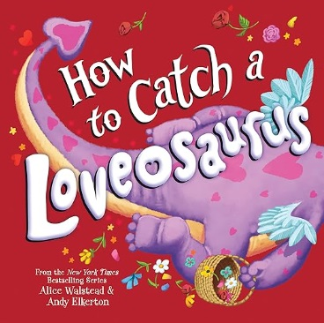Book: How to Catch a Loveosaurus: A Valentine's Day Adventure

Author: Alice Walstead

Ages: 3-6 years old

Source: <https://www.amazon.com/How-Catch-Loveosaurus-Alice-Walstead/dp/1728268788/>

Description from Amazon: “Can you catch the magical Loveosaurus? The How to Catch Kids are on the chase again, this time to trap a dinosaur that escaped from the museum and wants to spread love and kindness. Blending exciting traps and STEAM concepts with hilarity and chaos to encourage reading, learning, and imagination, this charming adventure will delight young readers, families, and educators alike…”

Book: The Funniest Valentine Joke Book for Kids: Packed With Hilarious Jokes, Riddles, Puns & Bonus Puzzles! A Valentine’s Day Gift For Kids 8-12

Author: TG Edition

Ages: 8-12 years old

Source: <https://www.amazon.com/Funniest-Valentine-Joke-Book-Kids/dp/B0DR2VVWHQ/>

Description from Amazon: “Welcome to a Valentine’s Day Full of Laughter! Dive into a world of giggles, smiles, and endless Valentine’s Fun! Get ready to make this Valentine’s Day one to remember!”